BHARATIYA VIDYA BHAVAN’S MEHTA VIDYALAYA, K.G. MARG, NEW DELHI
Class - 6
Summer Holiday Homework (2020-21)

ENGLISH
Create a scrapbook about your family.
- Draw your family tree (show creativity)
- Then interview five different members of your family or relatives and showcase them in your scrapbook.
Mention:
a. How you interviewed them (in person, on the phone, letter, email, Skype, WhatsApp...)
b. How they are related to you.
  - Where they were born.
  - Where they spent their childhood.
  - Their favourite memory/real life story from childhood.
  - Did they ever witness a pandemic like COVID-19?
  - What do they feel about COVID-19 and what they suggest you to do.
  - Make an illustration (drawings/ paintings / collage collection) of the childhood stories shared by your family members or relatives.
MATHS
Record the total positive Covid-19 cases of India for a week (18th May 2020 to 24th May 2020) as reported at 5 pm every day and then:
- Write those ' numbers' in Indian and International Number System.
- Also arrange them in ascending and descending order.
- Do it on A3 size colour sheet. Try to show your creativity as much as possible to depict your work.

Complete the following worksheet and attach with your holiday homework.

Q1- Write the following numbers in words in the Indian system of numeration
- 4,05,045 (ii) 35, 42, 012 (iii) 7, 06, 04, 014 (iv) 25, 05, 05,500

Q2- Rewrite each of the following numerals with proper commas in the international system of numeration. Also,
write the number name of each in the international system of numeration: (i) 4035672 (ii) 65954923
(iii) 70902005

Q3- Write each of the following in numeral form
- Thirty lakh eleven thousand one.
- Eight crore four lakh twenty-five.
- Three crore three lakh three thousand three hundred three.
- Seventeen crore sixty lakh thirty thousand fifty-seven.
- Seven million three hundred three thousand two hundred six.
- Fifty-five million twenty-nine thousand seven.
- Six billion one hundred ten million three thousand seven.

Q4-Write the corresponding numeral for each of the following:

- 7 × 1000 + 2 × 1000 + 5 × 100 + 9 × 10 + 6 × 1
ii. 4 × 100000 + 5 × 1000 + 1 × 100 + 7 × 1
iii. 8 × 1000000 + 3 × 1000 + 6 × 1
iv. 5 × 10000000 + 7 × 1000000 + 8 × 1000 + 9 × 10 + 4

Q5- Arrange the following numbers in ascending order:

(i) 102345694, 8354208, 6539542, 63547201, 12345678

Q6- Arrange the following numbers in descending order:
(i) 56943300, 56943201, 5695440, 56944000, 5694437

Q7- Answer the following questions:
i What comes just after 2779999?
ii What comes just before 1110000?
Iii What comes just before 10011000?

Q8- Interchange the digits in hundreds and tens place in the number 54,150. Can you tell if the value of new number
will increase or decrease and by how much?

Q9- Kirti Bookstore sold books worth Rs.2,85,891 in the first week of June and books worth Rs.4,00,768 in the
second week of the month. How much was the sale for the two weeks together? In which week was the sale
greater and by how much?

Q10-Determine the product of the place values of two fives in 450758.

Q11-Determine the difference between the place value and the face value of 5 in 78654321.

Q12- Write the smallest 3-digit number which does not change if the digits are in reverse order.

Q13-Write the roman-numerals for each of the following:
(i) 76 (ii) 95 (iii) 154 (iv) 173 (v) 248 (vi) 319

Q14-Write the following in Hindu-Arabic numeral
(i) LXXII (ii) XCI (iii)CIX (iv) CLXXII (v) CCLIV (vi) CCCXXIX

Q15-Solve these using suitable arrangement and properties
a) 17×108 b) 102×103 c) 137+908+463 d) 25×7534×4×50×2 e) 150×58+42×15×10

Q16-Give successor of each of the following whole numbers:
(i) 1000909 (ii) 2340900 (iii) 7039999

Q17- Write down the predecessor of each of the following whole numbers:
(i) 10000 (ii) 807000 (iii) 7005000

Q18- How many whole numbers are there between 21 and 61?

SCIENCE
Research based activity-

- Learn about the types of food that are eaten in different parts of India. Write a report about what you find.
- Prepare a diet chart to provide balanced diet to an eleven-year-old child.
Note-
Do both these activities on A-4 sheets. Complete the assignment given in loose sheets and submit in a folder.

Science Assignment:

- Fill in the blank.
  - Food ingredients contain some components that are needed by our body. These components are needed by our body. These components are called ___.
  - Starch and sugars are source of ____________. iii. Ground nut is rich in ____________. iv. Pulses and soya bean are source of ________.
  - The diet rich in all the nutrients is called ___________.
  - Disease that occur due to lack of nutrients over a long period are called _______.

- Match the column.
 | A  Vitamin/Mineral | B  Deficiency Disease
 | A | Beriberi
 | B | Bone and tooth decay
 | C | Rickets
 | D | Anaemia
 | Iodine | Scurvy
 | Calcium | Goiter
 | Iron | Loss of vision

- Define Balanced Diet?
_________________________________________________________________________________________
_________________________________________________________________________________

- Draw some sources of carbohydrates.

5.

Draw some plant and animal sources of protein.

Plant Source (Proteins) Animal Source (Proteins)

6. Tick (✔) the statements that are correct.
- Protein is a body building food.
- Vitamin C gets easily destroyed by heat during cooking.
iii. Our body does not need dietary fibre and water.
SOCIAL STUDIES
- Revision of all chapters and worksheets which have been completed.
- Repeat two Map activities from History.
- Decorate a Scrap Book and paste colourful pictures of corona warriors of our country showing gratitude towards them.
- All planets are named after ancient Greek and Roman Gods. Find out few interesting facts about the planets – Mars and Jupiter. Draw or paste the diagram of these planets also.
COMPUTER SCIENCE
Draw a table in MS-Word as shown.

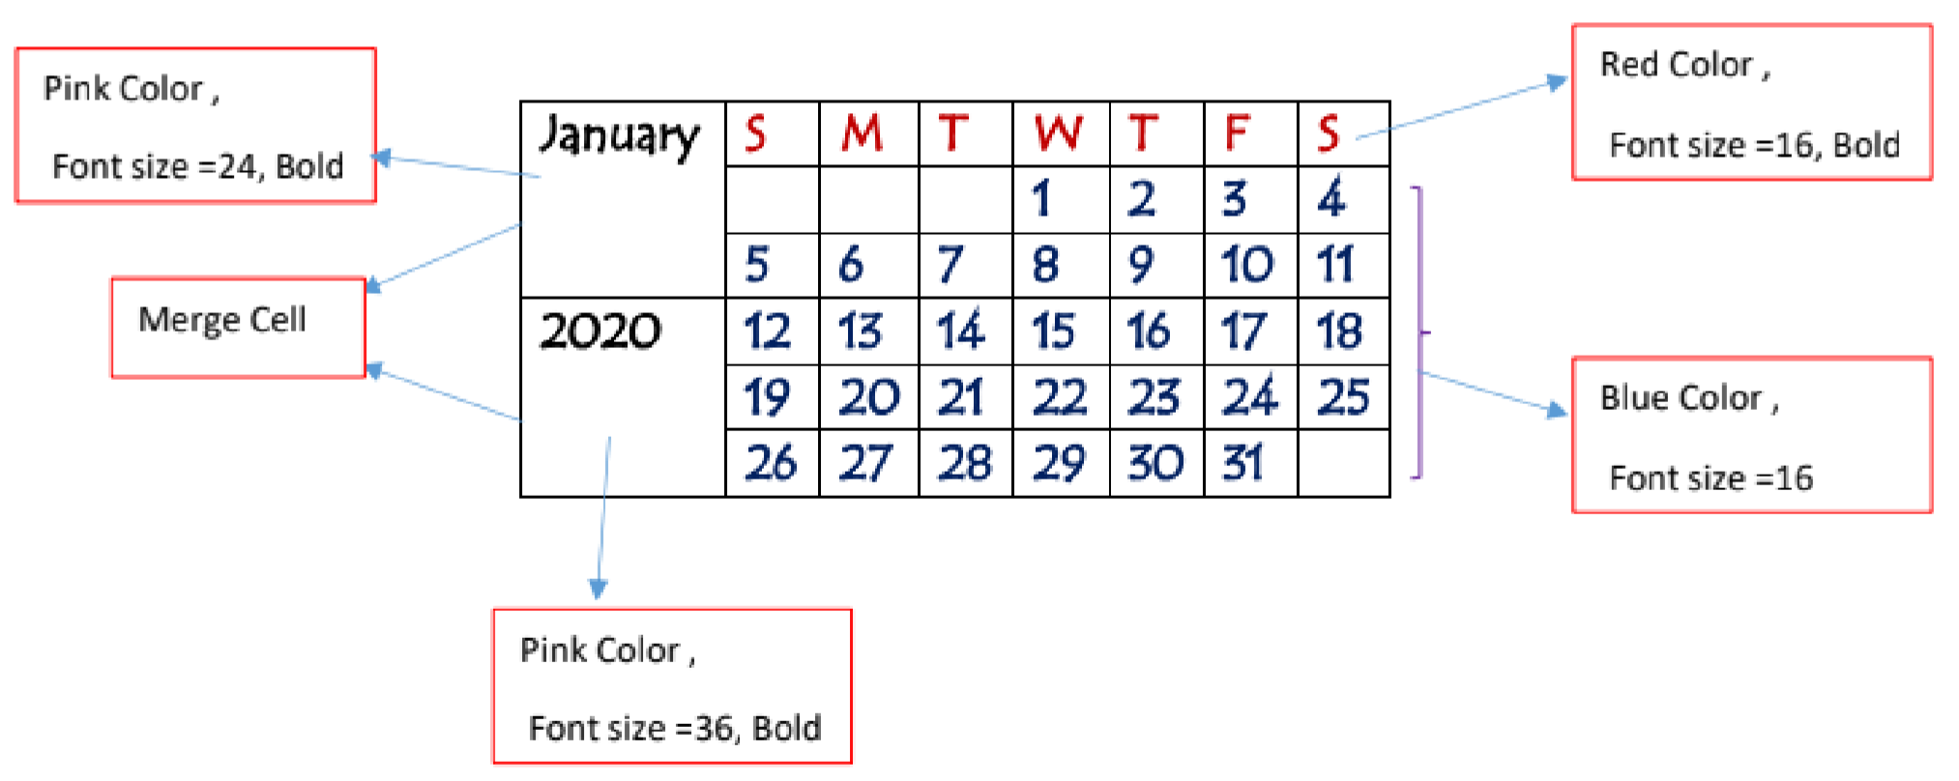

हिन्दी ग्रीष्म अवकाश गृि कार्य ᭅ

